
NEXAM: AN INTELLIGENT EXAMINATION MANAGEMENT, ASSESSMENT AND PROCTORING PLATFORM
THIRD YEAR
MINI PROJECT REPORT
Submitted by
SONIYA -24623141

POOJITHA – 24623135

SHARMILA – 24623147

In Partial fulfillment of the requirements for the award of the degree of
BACHELOR OF TECHNOLOGY IN CSE-
ARTIFICIAL INTELLIGENCE

DEPARTMENT OF ARTIFICIAL INTELLIGENCE AND MACHINE LEARNING SCHOOL OF ENGINEERING
VELS INSTITUTE OF SCIENCE, TECHNOLOGY AND ADVANCED STUDIES (VISTAS)
CHENNAI – 600 117
OCTOBER 2026

BONAFIDE CERTIFICATE
Certified that this project report "NEXAM: AN INTELLIGENT EXAMINATION MANAGEMENT, ASSESSMENT AND PROCTORING PLATFORM" is the bonafide work of SONIYA – 24623141, POOJITHA – 24623135 and SHARMILA – 24623147, who carried out the project under my supervision. Certified further that, to the best of my knowledge, the work reported herein does not form part of any other project report or dissertation on the basis of which a degree or award was conferred on an earlier occasion on this or any other candidate.

SIGNATURE OF THE HOD  Dr K. ULAGA PRIYA, M.E., Ph.D.  Associate Professor & Head  Department of AI&ML  School of Engineering  VISTAS, Chennai | SIGNATURE OF THE SUPERVISOR  Ms. MOHANA PRIYA, M.E,(Ph.D.)  Associate Professor  Department of AI&ML  School of Engineering  VISTAS, Chennai

Submitted for the Project Work and Viva-Voce examination held on 30.10.2026 at Vels Institute of Science, Technology and Advanced Studies (VISTAS), Chennai – 600 117.

INTERNAL EXAMINER | EXTERNAL EXAMINER

DECLARATION
We hereby declare that the mini project report entitled "NEXAM: AN INTELLIGENT EXAMINATION MANAGEMENT, ASSESSMENT AND PROCTORING PLATFORM", submitted to Vels Institute of Science, Technology and Advanced Studies (VISTAS), Chennai, in partial fulfillment of the requirements for the award of the degree of Bachelor of Technology in Computer Science and Engineering (Artificial Intelligence), is a record of original work carried out by us under the guidance of Ms. Mohana Priya, Assistant Professor, Department of Artificial Intelligence and Machine Learning. The work has not been submitted, in part or in full, for the award of any other degree or diploma.

Place: Chennai
Date: 30.10.2026

SONIYA – 24623141
POOJITHA – 24623135
SHARMILA – 24623147
ACKNOWLEDGEMENT
It is a great pleasure and privilege to acknowledge the help and support we received in completing this project. The infrastructure and laboratory facilities provided by our FOUNDER & CHAIRMAN, Shri. Dr. ISHARI K. GANESH, have been a constant source of motivation, and we take this opportunity to thank him. We are grateful to our HEAD OF THE DEPARTMENT, Dr.K. ULAGA PRIYA, for continuous support and encouragement throughout the project. We extend our sincere thanks to our INTERNAL GUIDE, Ms. MOHANA PRIYA, M.E,(Ph.D.) Assistant Professor, Department of AI&ML, who patiently guided us and gave us invaluable advice at every stage of the work. We also thank the faculty members, librarian and non-teaching staff of the department for their help. Finally, we thank our parents and friends for their support and encouragement, without which this project would not have been possible.

SONIYA – 24623141
POOJITHA – 24623135
SHARMILA – 24623147
ABSTRACT
NEXAM is an intelligent examination management, assessment and proctoring platform designed to make online examinations organized, efficient and trustworthy. Conventional online examinations capture students' answers but not the integrity of the session. NEXAM addresses this by combining three functions in a single web application: examination management, face-based identity verification and real-time integrity monitoring. Faculty members create examinations, manage multiple-choice questions, assign examinations to classes and set examination windows, while students attempt the examinations assigned to their class through a dashboard. During registration, the student's email address is verified and a face is captured, from which a facial descriptor is extracted with face-api.js. Before the examination, the student's live webcam image is compared with the registered descriptor. During the examination, the system monitors the webcam and the browser and records anomalies such as a missing face, multiple faces, an unrecognized face, tab switching and leaving fullscreen as timestamped violations linked to the submission, together with a session recording that faculty can review. Objective answers are evaluated automatically and results are presented as scores, percentages and class-wise reports with an integrity status, and students may request a reattempt. The platform is built with React and TypeScript, Node.js and Express, and SQLite, and performs facial analysis on the student's device, requiring no special hardware or paid proctoring service. Flags are presented as evidence for faculty review rather than automatic penalties, recognizing the possibility of false positives and the privacy obligations of handling biometric data.
Keywords: online examination, proctoring, face verification, face-api.js, academic integrity, React, Node.js, Express, SQLite.
TABLE OF CONTENTS
CHAPTER NO. | TITLE | PAGE NO.
 | ABSTRACT | i
 | LIST OF FIGURES AND TABLES | iv
 | LIST OF ABBREVIATIONS | v
1 | CHAPTER 1 – INTRODUCTION | 1
 | 1.1 Introduction to online examination systems | 1
 | 1.2 Background and motivation | 1
 | 1.3 Problem statement | 1
 | 1.4 Aim and objectives | 2
 | 1.5 Scope of the project | 2
 | 1.6 Significance of NeXAM | 2
 | 1.7 Organization of the report | 3
2 | CHAPTER 2 – REVIEW OF LITERATURE | 4
 | 2.1 Online examination management systems | 4
 | 2.2 Online assessment and automated evaluation | 4
 | 2.3 Face-based identity verification | 4
 | 2.4 AI-assisted online proctoring | 5
 | 2.5 Browser activity and examination monitoring | 5
 | 2.6 Literature survey | 5
 | 2.7 Research gap | 6
 | 2.8 How NeXAM addresses the identified problems | 6
3 | CHAPTER 3 – SYSTEM DESIGN | 7
 | 3.1 Existing system and its limitations | 7
 | 3.2 Proposed NeXAM system | 7
 | 3.3 Functional requirements | 8
 | 3.4 Non-functional requirements | 8
 | 3.5 System architecture | 9
 | 3.6 Use-case diagram | 9
 | 3.7 Data-flow diagrams | 10
 | 3.8 System workflow | 11
 | 3.9 Database design and tables | 12
 | 3.10 Hardware requirements | 13
 | 3.11 Software requirements | 14
 | 3.12 Security and privacy considerations | 14
4 | CHAPTER 4 – IMPLEMENTATION | 15
 | 4.1 System modules and overall workflow | 15
 | 4.2 Module implementation | 15
 | 4.2.1 Student Registration and Email Verification | 15
 | 4.2.2 Login and Access Control | 16
 | 4.2.3 Faculty Dashboard | 16
 | 4.2.4 Examination Creation and Management | 16
 | 4.2.5 Question Bank and Examination Assignment | 16
 | 4.2.6 Student Examination Interface | 16
 | 4.2.7 Face-Based Identity Verification | 16
 | 4.2.8 Webcam-Based Facial Monitoring | 17
 | 4.2.9 Tab-Switching and Fullscreen Activity Monitoring | 17
 | 4.2.10 Violation Logging and Timestamps | 17
 | 4.2.11 Objective-Question Evaluation | 17
 | 4.2.12 Result Generation and Class-Wise Reports | 17
 | 4.2.13 Reattempt Request | 18
 | 4.3 SQLite database integration | 18
 | 4.4 Frontend and backend integration and API design | 18
5 | CHAPTER 5 – RESULTS, TESTING AND CONCLUSION | 19
 | 5.1 Implemented features and screenshots | 19
 | 5.2 Test plan and test cases | 20
 | 5.3 Testing results | 21
 | 5.4 Discussion | 22
 | 5.5 Advantages of the system | 22
 | 5.6 Limitations | 22
 | 5.7 Conclusion | 23
 | 5.8 Future enhancements | 23
 | APPENDIX A-CONFERENCE PAPER CERTIFICATES | 23
 | REFERENCES | 24
LIST OF FIGURES
FIGURE NO. | TITLE | PAGE NO.
3.1 | System architecture of NeXAM | 9
3.2 | Use-case diagram | 10
3.3 | Data-flow diagram – Level 0 (context) | 10
3.4 | Data-flow diagram – Level 1 | 11
3.5 | Examination session workflow | 12
3.6 | Database design (tables from the project architecture) | 13
4.1 | Project schedule (Gantt chart from the project presentation) | 15
5.1 | Landing page | 21
5.2 | Registration with email verification code | 21
5.3 | Face capture during registration | 21
5.4 | Student examination dashboard | 21
5.5 | Faculty assessment command center | 21
5.6 | Create an exam – exam details | 21
5.7 | Adding an MCQ question | 22
5.8 | Assigning an exam to classes | 22
5.9 | Reattempt notice and request | 22
5.10 | Class-wise report with integrity status | 22
5.11 | Students and recordings for review | 22
5.12 | Session recording with a timestamped flag | 22
LIST OF TABLES
TABLE NO. | TITLE | PAGE NO.
2.1 | Literature survey | 5
3.1 | Feature status | 7
3.2 | Functional requirements | 8
3.3 | Database tables | 13
3.4 | Hardware requirements | 13
3.5 | Software requirements | 14
4.1 | Logical API groups (route names to be confirmed) | 18
5.1 | Test cases | 21
LIST OF ABBREVIATIONS
ABBREVIATION | FULL FORM
AI | Artificial Intelligence
API | Application Programming Interface
CPU | Central Processing Unit
DFD | Data-Flow Diagram
HTTP | Hypertext Transfer Protocol
IEEE | Institute of Electrical and Electronics Engineers
JSON | JavaScript Object Notation
LFW | Labeled Faces in the Wild
LMS | Learning Management System
MCQ | Multiple-Choice Question
RAM | Random Access Memory
REST | Representational State Transfer
SQL | Structured Query Language
UI | User Interface

CHAPTER 1 – INTRODUCTION

1.1 INTRODUCTION TO ONLINE EXAMINATION SYSTEMS
An online examination system allows an institution to create, deliver and evaluate examinations through a web application instead of on paper. Such systems shorten the time between an examination and its results, allow students to take tests from any connected computer, and reduce the clerical work of faculty. Their weakness is integrity: an online examination records what a student answers, but not who answered it or how. Without an invigilator in the room, impersonation, use of other browser tabs and help from other people are difficult to detect [1]. NEXAM is an intelligent examination management, assessment and proctoring platform developed to address this weakness. It is built on three pillars presented in the project: examination management, which lets faculty conduct examinations online; identity verification, which confirms that the person taking the examination is the person who registered; and integrity monitoring, which records irregular activity during the examination. The platform is a web application with a React and TypeScript frontend, a Node.js and Express backend, an SQLite database and face-api.js for facial analysis in the browser [2].

1.2 BACKGROUND AND MOTIVATION
The wide adoption of online assessment has made academic integrity an everyday concern for colleges. Commercial proctoring services exist, but they are usually paid, closed-source and dependent on third-party infrastructure, and research on AI-based proctoring has raised concerns about privacy, fairness and the cost of such tools [1], [3]. Research systems that detect cheating often require extra hardware, such as a worn camera, a fingerprint reader or an eye tracker [4], [5].
The motivation for NEXAM, as stated in the project presentation, is fourfold: to build integrity checks into the examination flow itself rather than adding them afterwards; to follow a college → department → class structure so that an institution can adopt it without custom work; to log every flagged incident against the submission so that faculty have concrete evidence to review; and to run entirely in the browser without paid proctoring subscriptions, dedicated invigilators or special hardware.

1.3 PROBLEM STATEMENT
Conventional online examination tools capture answers but not honesty. In particular:
- Identity is not verified: a password alone does not show that the registered student is the person taking the examination.
- Session behaviour is not observed: switching to other tabs, leaving full screen, the student leaving the camera view or a second person appearing go unnoticed.
- Evidence is missing: when misconduct is suspected, there is usually no timestamped record or recording for faculty to review.
- Tools are fragmented: examination creation, proctoring, evaluation and reporting are often handled by separate systems.
The problem addressed by this project is to design and implement a single, browser-based platform that manages the complete examination lifecycle while verifying student identity and recording integrity events for faculty review.

1.4 AIM AND OBJECTIVES
The aim of the project is to develop a web-based examination platform that combines examination management, face-based identity verification and real-time integrity monitoring. The objectives are:
- To provide registration for students and faculty with email verification and face capture.
- To allow faculty to create examinations, add multiple-choice questions, assign examinations to classes and set examination windows.
- To verify a student's identity with face-api.js before the examination by comparing a live face with the registered face.
- To monitor the examination session for missing, multiple or unrecognized faces, tab switching and fullscreen exit, and to log each event with a timestamp.
- To evaluate objective answers automatically and present results as scores and percentages.
- To provide faculty with class-wise reports, session recordings and violation flags, and to let students request a reattempt.

1.5 SCOPE OF THE PROJECT
- Users: students and faculty of a college organized into departments and classes.
- Assessment type: objective (multiple-choice) examinations with four options per question and per-question marks.
- Proctoring: webcam-based face checks and browser activity monitoring performed in the student's browser, with session recording and timestamped flags.
- Technology: React with TypeScript, Node.js with Express, SQLite and face-api.js.
- Out of scope for the current version: descriptive, image-based and coding answers; voice and object detection; integration with external learning management systems. These are discussed as future enhancements (Section 5.8).

1.6 SIGNIFICANCE OF NEXAM
- Integrity by design: identity verification and monitoring are part of the examination flow.
- Evidence for faculty: each flag is stored with its time and linked to a submission and recording, so faculty decide on the basis of evidence rather than suspicion.
- Low cost and on-device analysis: facial analysis runs in the browser through face-api.js and TensorFlow.js, so no paid proctoring service or server-side machine-learning infrastructure is required [2], [6].
- Single platform: examination creation, delivery, proctoring, evaluation and reporting are handled in one application.

1.7 ORGANIZATION OF THE REPORT
Chapter 2 reviews literature on online examination systems, automated evaluation, face-based verification, AI-assisted proctoring and browser monitoring, including the base paper, and identifies the research gap. Chapter 3 presents the system design: requirements, architecture, use cases, data flow, workflow, database design and security considerations. Chapter 4 describes the implementation of each module. Chapter 5 presents the implemented features, test cases, discussion, limitations, conclusion and future enhancements.

CHAPTER 2 – REVIEW OF LITERATURE

2.1 ONLINE EXAMINATION MANAGEMENT SYSTEMS
Online examination management systems organize the creation of examinations, the delivery of questions to authorized students within a time window, and the storage of responses. A systematic review of 43 studies on AI-based and online proctoring published between 2015 and 2021 found that, alongside their convenience, these systems raise security, privacy, ethical, trust and cost concerns, and that whether their benefits outweigh their risks is difficult to establish [1]. These findings indicate that an examination system should be designed with integrity and ethics in mind from the start.

2.2 ONLINE ASSESSMENT AND AUTOMATED EVALUATION
Objective questions can be evaluated automatically by comparing each response with an answer key, which removes manual marking effort and returns results immediately. The base paper for this project, by Carrasco, Rito Silva and Henriques, studies multiple-choice online tests and shows that the response data itself can also reveal misconduct: it proposes a statistical method that analyzes answer concordance and response timing between students, builds a communication network, clusters students and applies null models and statistical testing to separate suspicious agreement from normal similarity [7]. The study used quiz data from the Quizzes Tutor platform at Técnico Lisboa, from Software Architecture and Software Engineering courses with short, randomized multiple-choice quizzes. Its authors note that the method relies on answer patterns and timestamps rather than direct observation, and that continuous authentication, proctoring and browser-tab monitoring are complementary strategies. NEXAM follows this direction by adding identity verification and session monitoring to automated evaluation.

2.3 FACE-BASED IDENTITY VERIFICATION
Modern face verification maps a face image to a compact numerical embedding, so that two images of the same person produce nearby vectors. FaceNet showed that such embeddings, learned directly with a triplet loss, support verification by a simple distance threshold [8]. face-api.js brings this approach to the browser: built on TensorFlow.js, it provides face detectors (SSD Mobile Net V1 and a Tiny Face Detector), a 68-point landmark model and a ResNet-34-like recognition model that produces a 128-value face descriptor, equivalent to the dlib face recognition network [2], [6], [9]. The library reports 99.38% accuracy for its recognition model on the LFW benchmark; this is the library's published figure, not a measurement of NEXAM. Fenu, Marras and Boratto proposed continuous student authentication in e-learning using several biometric traits, including face, voice, touch, mouse and keystroke dynamics, showing that identity can be checked throughout a session rather than only at login [10].

2.4 AI-ASSISTED ONLINE PROCTORING
Atoum et al. developed an automated online exam proctoring system that uses a webcam, a worn camera and a microphone and combines user verification, text detection, voice detection, active-window detection, gaze estimation and phone detection [4]. Prathish, Narayanan and Bijlani proposed a multimodal monitoring system that uses webcam video and audio together with active-window capture and a rule-based inference engine based on head-pose yaw, audio presence and window activity [11]. Chuang, Craig and Femiani studied head pose and the time delay before answers in 42 students and reported that the approach predicted cheating with 75.6% accuracy, while about 10% of cases were falsely flagged; the authors presented it as a resource to support, not replace, human judgement [12]. Bawarith et al. combined a fingerprint reader for authentication with an eye tracker that detects when the examinee looks away or leaves the screen [5].
The ethics of such tools have been examined by Coghlan, Miller and Paterson, who discuss fairness, non-maleficence, transparency, privacy, autonomy, liberty and trust, note that students have described proctoring as "Big Brother-like", and argue that institutions should weigh these considerations before deploying any system [3].

2.5 BROWSER ACTIVITY AND EXAMINATION MONITORING
Browsers provide standard interfaces that an examination page can use to observe the session: the Page Visibility API reports when a page becomes hidden, for example when the student switches tabs or minimizes the window; the Fullscreen API allows a page to request fullscreen and detect when it is exited; and the MediaStream Recording API records webcam streams [13], [14], [15]. Active-window monitoring has been used in earlier proctoring research [4], [11]. Because these signals can also be triggered innocently, they are best treated as indicators for review rather than proof of misconduct.

2.6 LITERATURE SURVEY
Table 2.1: Literature survey
Author (year) | Methodology | Findings | Limitations (relative to NeXAM's goals)
Carrasco et al. (2024) – base paper [7] | Statistical analysis of answer concordance and response time; communication network, clustering and null-model testing | Identifies potential collusion and communication roles in MCQ tests | Relies on answer patterns; no direct observation, identity check or browser monitoring
Atoum et al. (2017) [4] | Webcam, worn camera and microphone; verification, text, voice, window, gaze and phone detection | Multimedia analytics can detect several cheating behaviors | Needs additional wearable hardware and heavier processing
Prathish et al. (2016) [11] | Webcam video, audio and active-window capture with a rule-based inference engine | Combining head pose, audio and window activity can replace a physical proctor | No identity verification against a registered face in the described method
Bawarith et al. (2017) [5] | Fingerprint authentication and eye tracker | Classified sessions using time away from screen and look-away count | Requires fingerprint reader and eye tracker
Chuang et al. (2017) [12] | Head pose and answer time delay in 42 students | 75.6% predictive accuracy; about 10% false flags | Small sample; indicators need human judgement
Fenu et al. (2018) [10] | Continuous multi-biometric authentication (face, voice, touch, mouse, keystroke) | Identity can be checked throughout a session | Relies on several biometric modalities and device interactions
Nigam et al. (2021) [1] | Systematic review of 43 studies (2015–2021) | Privacy, ethics, trust and cost are major issues | Review; no system proposed
Coghlan et al. (2020) [3] | Ethical analysis of exam supervision technologies | Fairness, privacy, transparency and autonomy must be weighed | Analysis; no system proposed

2.7 RESEARCH GAP
- Response-data analysis, such as the base paper, does not observe the examination session or verify identity [7].
- Several proctoring systems depend on extra hardware or heavier processing, which limits adoption by ordinary colleges [4], [5].
- Behavioral indicators produce false flags and require human review, yet many systems report alerts without linking them to a specific submission and recording [12], [3].
- Examination management, identity verification, proctoring, evaluation and reporting are rarely combined in one low-cost, browser-based platform.

2.8 HOW NEXAM ADDRESSES THE IDENTIFIED PROBLEMS
- Identity: a face descriptor captured at registration is compared with a live face before the examination.
- Observation: the browser monitors the face and tab and fullscreen activity and records the session, complementing response-based analysis.
- Low barrier: facial analysis runs on-device with face-api.js; only a webcam and a modern browser are needed.
- Evidence and review: every violation is timestamped and linked to the submission and recording, and faculty make the final decision.

CHAPTER 3 – SYSTEM DESIGN

3.1 EXISTING SYSTEM AND ITS LIMITATIONS
In the existing approach, colleges conduct online tests with general-purpose form or quiz tools, sometimes supervised over a video call. Answers are collected and may be graded automatically, but the student's identity is assumed from the login, session behavior is not recorded, and faculty must manually watch several video feeds if they supervise at all. The main limitations are: no identity verification at the start of the examination; no record of tab switching or leaving fullscreen; no timestamped evidence linked to a submission; dependence on paid proctoring services for automated supervision; and separate tools for creation, supervision and reporting.

3.2 PROPOSED NeXAM SYSTEM
NEXAM integrates examination management, identity verification and integrity monitoring in a single web application. Faculty create and assign examinations; students register with a face image, verify their email and take examinations in a monitored, fullscreen session; violations are logged with timestamps; objective answers are scored automatically; and faculty review results, recordings and flags. Table 3.1 summarizes the status of each feature based on the available project evidence.
Table 3.1: Feature status
Feature | Status | Evidence
Registration with email code and face capture | Implemented | Figures 5.2, 5.3
Class-based examination dashboard with exam windows | Implemented | Figure 5.4
Exam creation, MCQ questions, marks and class assignment | Implemented | Figures 5.6–5.8
Faculty command center (exams, submissions, average score, incidents) | Implemented | Figure 5.5
Session recording with timestamped flags and "Jump to moment" | Implemented | Figures 5.11, 5.12
Automatic scoring with percentages; auto-submission | Implemented | Figure 5.10
Reattempt notice and request (student side) | Implemented | Figure 5.9
Face verification before the exam; multiple/unrecognized face flags | Described in presentation | Figure 5.3
Tab-switch and fullscreen monitoring | Described in presentation | Figure 5.11
Faculty approval of reattempt requests | To be confirmed | Planned for future enhancement
Eye tracking, head pose, voice detection, screen capture, integrity score | Shown in a presentation design image only | Future enchancement
Text, image and coding evaluation; email notifications; LMS (Moodle) integration | Planned (Gantt chart / architecture slide) | Future enhancement

3.3 FUNCTIONAL REQUIREMENTS
Table 3.2: Functional requirements
ID | Requirement | User
FR1 | Register as student or faculty with name, email, password, department and class | Student, Faculty
FR2 | Verify the email address with a one-time code sent by email | Student, Faculty
FR3 | Capture a face image at registration and store its descriptor | Student
FR4 | Log in and reach a role-specific dashboard | Student, Faculty
FR5 | Create an exam with title, subject, duration, start and end time and description | Faculty
FR6 | Add MCQ questions with four options, a correct option and marks | Faculty
FR7 | Assign an exam to one or more classes | Faculty
FR8 | Show only exams assigned to the student's class, within the exam window | Student
FR9 | Verify the student's face before the exam starts | Student
FR10 | Monitor face presence, multiple or unrecognized faces, tab switching and fullscreen exit; log each event with a timestamp | System
FR11 | Record the session and auto-submit when the violation rule is met | System
FR12 | Evaluate answers automatically and store score and percentage | System
FR13 | Show class-wise scores with integrity status, and recordings with flags | Faculty
FR14 | Block a second attempt and allow a reattempt request with a reason | Student

3.4 NON-FUNCTIONAL REQUIREMENTS
- Usability: clear dashboards for students and faculty; usable without training.
- Performance: face checks must run in real time in the browser on ordinary laptops; for frame rate and latency.
- Reliability: answers and violations must be saved even if the session ends unexpectedly.
- Security and privacy: passwords stored securely, access restricted by role, biometric data protected (Section 3.12).
- Portability: runs in a modern desktop browser with a webcam; no special hardware.
- Fairness: flags are evidence for human review, not automatic penalties.

3.5 SYSTEM ARCHITECTURE
NEXAM follows a three-tier client-server architecture (Figure 3.1). The client tier is a React and TypeScript single-page application served at localhost:5173 during development. It contains the student portal, the faculty workspace and the proctoring monitors; face-api.js runs on-device to detect faces, compute landmarks and produce 128-value descriptors. The application tier is a Node.js and Express REST API at localhost:5000/api, organized into authentication, examination, submission, violation-logging and reporting functions. The data tier is an SQLite database. An external email service delivers verification codes.
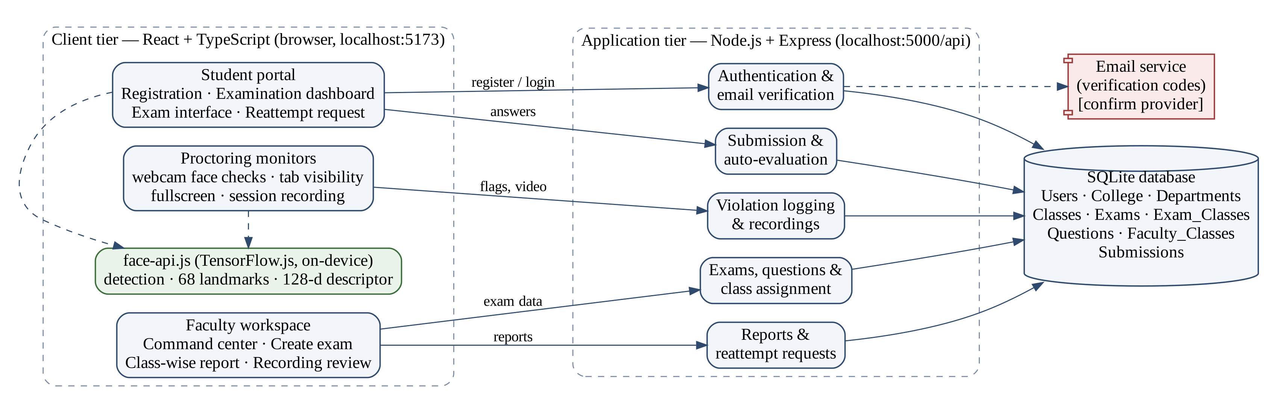
Figure 3.1: System architecture of NEXAM
The architecture slide in the project presentation also shows an authoring tool, scoring engine, correction database, a Moodle LMS, a remote test module and a team creator module. The LMS, remote test and team creator components are not part of the stated technology stack, and are treated in this report as conceptual or future components. The database layer in that slide (Users, College, Departments, Classes, Exams, Exam_Classes, Questions, Faculty_Classes and Submissions) is used in Section 3.9.
.

3.8 SYSTEM WORKFLOW
Figure 3.2 shows the workflow of one examination session from the student's side, from opening the dashboard to faculty review.
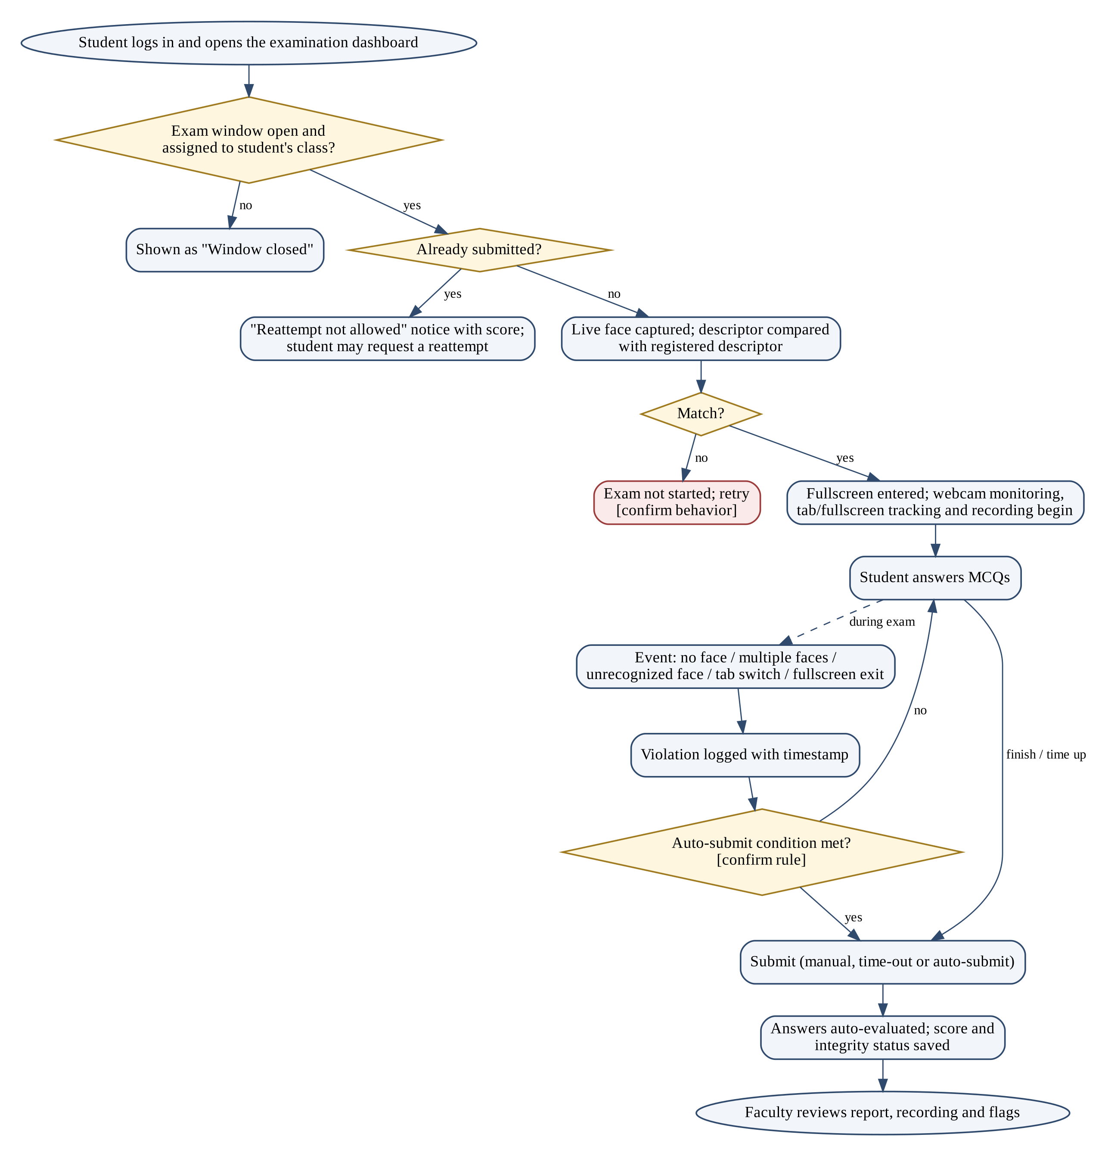
Figure 3.2: Examination session workflow
An examination can be started only while its window is open and only if it is assigned to the student's class. A student who has already submitted sees a "Reattempt not allowed" notice with the score and may request a reattempt. Otherwise the live face is compared with the registered face; on success the session enters fullscreen and monitoring and recording begin. Each violation is logged with its time. The examination ends by manual submission, time-out or auto-submission, after which answers are evaluated and the score and integrity status are stored. The exact face-mismatch behavior and auto-submission rule

Table 3.3: Database tables
Table | Purpose
Users | Students and faculty: name, email, hashed password, role, class, verification status and face descriptor
College, Departments, Classes | Institutional hierarchy (e.g., Computer Science → 3rd Year – Section A)
Faculty_Classes | Classes handled by each faculty member
Exams | Title, subject, duration, start and end time, description, creating faculty
Exam_Classes | Classes to which an exam is assigned
Questions | Question text, four options, correct option and marks
Submissions | Student answers, score, status (completed / auto-submitted) and submission time
Violations, reattempt requests, recordings | Storage location to be confirmed

3.10 HARDWARE REQUIREMENTS
Table 3.4: Hardware requirements
Component | Requirement
Client computer | Laptop or desktop with a dual-core or better CPU and 4 GB RAM or more
Webcam | Built-in or USB webcam (required for registration and proctoring)
Server | Machine able to run Node.js and store the SQLite file and recordings
Network | Stable connection between browser and server; internet for email verification

3.11 SOFTWARE REQUIREMENTS
Table 3.5: Software requirements
Software | Purpose
React with TypeScript (Vite development server) | Frontend single-page application
Node.js and Express | Backend REST API
SQLite | Embedded relational database
face-api.js on TensorFlow.js | On-device face detection, landmarks and descriptors
Email service | Delivery of verification codes
Google Chrome or another modern browser | Client with webcam, Fullscreen and Page Visibility support
Visual Studio Code, Git | Development tools

3.12 SECURITY AND PRIVACY CONSIDERATIONS
- Consent and transparency: students must be told before registration that a face image is captured, that the session is recorded, which events are flagged and how long data is kept, and must give consent [3].
- Biometric data: store only what is needed (the face descriptor, not raw images where possible); protect it with access control and encryption at rest delete it when no longer required.
- False positives: poor lighting, glasses, camera quality, a family member walking past or an accidental tab switch can raise flags. Flags are therefore evidence for review, not automatic verdicts; faculty must review the recording before any academic decision [12], [1].
- Fairness and accessibility: face detection accuracy can vary across users and conditions, and students with disabilities may need adjustments; reattempt requests provide a route for appeal.
- Account security: passwords should be hashed, the API should check the user's role on every request, and recordings should be accessible only to the responsible faculty

CHAPTER 4 – IMPLEMENTATION

4.1 SYSTEM MODULES AND OVERALL WORKFLOW
NEXAM was developed incrementally over ten weeks, from requirements analysis and system design through registration, examination management, face verification, monitoring, evaluation, reporting, integration and testing (Figure 4.1). The application is divided into the modules described in Section 4.2. The frontend handles user interaction, face analysis and session monitoring; the backend exposes REST endpoints for each module and stores data in SQLite.

4.2 MODULE IMPLEMENTATION

4.2.1 Student Registration and Email Verification
Purpose: create verified accounts linked to the college structure. Input: full name, email, password and confirmation, role, department, class and section, a one-time code and a webcam face capture. Process: the registration page (/register) sends a code to the email address ("Code sent. Check your college email inbox (and Spam).") with a "Resend code" option; the code is verified before the account is created. The "Face verification (required)" panel uses face-api.js to detect a face and shows "No face detected. Center your face in the frame." until one is found; the face descriptor is then computed for storage. Output: a verified account with a stored face descriptor. Technologies: React, face-api.js, Express, SQLite, email server(Figures 5.2, 5.3).

4.2.2 Login and Access Control
Purpose: authenticate users and route them by role. Input: email and password. Process: the backend checks the credentials and returns the user's role; students are taken to the Student Portal (/dashboard) and faculty to the faculty workspace (/faculty). Output: an authenticated session. The session mechanism (for example, a token) and password hashing method are confirm implementation.

4.2.3 Faculty Dashboard
The "Assessment command center" (/faculty) summarizes published exams, student submissions, average score and proctoring incidents, and lists the faculty member's examinations with their subject, duration and window, an "AI proctored" badge and a "View recordings" link. Buttons lead to exam creation, the student report and the student list (Figure 5.5).

4.2.4 Examination Creation and Management
Input: exam title, subject, duration in minutes, start and end time and description. Process: the "Create an exam" page (/create-exam) collects the exam details as step 1; the exam window (start and end time) controls when students can start it. Output: a stored exam record (Figure 5.6).

4.2.5 Question Bank and Examination Assignment
Questions are written manually in step 3 of the same page: the question text, all four options and the correct option (selected with a radio button), and the marks for the question. In step 2, "Assign to classes", the faculty member selects one or more classes (for example, 2nd Year – Section A, 3rd Year – Section A); only students in those classes can attempt the exam. Questions and assignments are stored in the Questions and Exam_Classes tables (Figures 5.7, 5.8).

4.2.6 Student Examination Interface
The Student Portal lists "Available examinations" with the note "Only exams assigned to your class appear here." Each card shows the exam name, status (OPEN NOW or CLOSED), subject, duration, marks and window; open exams have a "Start exam" button and closed exams show "Window closed" (Figure 5.4). During the exam, questions are presented one or more at a time and answers are submitted to the backend of the exam screen.

4.2.7 Face-Based Identity Verification
Purpose: confirm that the registered student is taking the examination. Process: before the exam starts, face-api.js detects the face in the live webcam image, computes its 128-value descriptor and compares it with the descriptor stored at registration using Euclidean distance; a distance below a threshold is treated as a match [2], [8]. According to the project abstract, the comparison is performed before and after the examination. Output: verified or not verified. The threshold value and the handling of a failed match are confirm threshold and behavior. The following illustrative code shows the face-api.js calls used for this kind of comparison; it is not taken from the NEXAM source code.

4.2.8 Webcam-Based Facial Monitoring
During the session, the webcam stream is analyzed periodically with face-api.js. The project abstract lists three facial anomalies: no face (student not in view), multiple faces (another person present) and unrecognized face (descriptor does not match the registered student). The session is also recorded so that faculty can watch it later; the recording format, storage location and retention period [15].

4.2.9 Tab-Switching and Fullscreen Activity Monitoring
The examination page enters fullscreen and listens for browser events that indicate the student has left it: a change in page visibility (switching tabs or minimizing the window) and an exit from fullscreen [13], [14]. Each event is recorded as a violation. The exact events handled and whether fullscreen is re-requested

4.2.10 Violation Logging and Timestamps
Each violation is stored with its type, a description and its time relative to the start of the recording, and is linked to the student's submission. In the recording review (/exam-recordings/{exam id}), faculty see the list of students in roll-number order with status, score, number of flags and submission time; selecting "Review" shows the session recording and a "Flags" table. For example, the flag at 00:12 has the type "No face" and the detail "No face detected in front of the camera.", and "Jump to moment" moves the video to that time (Figures 5.11, 5.12). When the auto-submission rule is met, the submission is marked "Auto-submitted" (Figure 5.10).

4.2.11 Objective-Question Evaluation
When a submission is received, each answer is compared with the correct option and the marks of correctly answered questions are added. The score is stored with the total and a percentage (for example, 10/20 = 50%). Evaluation is immediate and requires no manual marking.

4.2.12 Result Generation and Class-Wise Reports
The student report (/student-report) lets faculty select a class and see every student with the exam, score and percentage, integrity status and submission time. The integrity status is "Clear" when no incidents were logged, or shows the number of incidents and "Auto-submitted" when applicable (Figure 5.10).

4.2.13 Reattempt Request
If a student opens an exam that has already been submitted (/exam/{exam id}), the system shows "Reattempt not allowed" with the score and a text box ("If this was a mistake (e.g. accidental submission, technical issue), explain briefly…"), with "Request a reattempt" and "Back to dashboard" buttons (Figure 5.9). How faculty view and approve requests .

4.3 SQLITE DATABASE INTEGRATION
The backend stores all persistent data in a single SQLite database file using the tables in Table 3.3. SQLite was chosen because it is serverless, requires no separate database administration and stores the whole database in one file, which suits a departmental deployment [16]. Relationships follow the college → department → class hierarchy, so that class assignment and class-wise reports are simple joins. The Node.js SQLite driver and the schema creation method.

4.4 FRONTEND AND BACKEND INTEGRATION AND API DESIGN
The React frontend (localhost:5173) calls the Express backend (localhost:5000) through JSON requests under the /api prefix; the presentation screenshots show exam resources addressed as /api/exams/{id}/… [17], [18]. Table 4.1 lists the logical API groups required by the modules; exact route names and methods must be taken from the source code. Because facial analysis runs in the browser, the server does not process video frames, which keeps it lightweight confirm.
Table 4.1: Logical API groups (route names to be confirmed)
Group | Operations | Used by
Authentication | Register, send and verify email code, log in | Registration and login pages
Examinations | Create exam, add questions, assign classes, list exams for a class or faculty member | Faculty workspace, Student Portal
Submissions | Start attempt, submit answers, auto-submit, evaluate | Exam interface
Proctoring | Record violation with type, detail and timestamp; upload recording | Proctoring monitors
Reports and review | Class-wise scores, recordings and flags per exam, dashboard statistics | Faculty workspace
Reattempts | Create reattempt request with reason [confirm route approval] | Exam page, faculty

CHAPTER 5 – RESULTS, TESTING AND CONCLUSION

5.1 IMPLEMENTED FEATURES AND SCREENSHOTS
The following screenshots were captured from the running application (frontend at localhost:5173) and are reproduced from the project presentation.
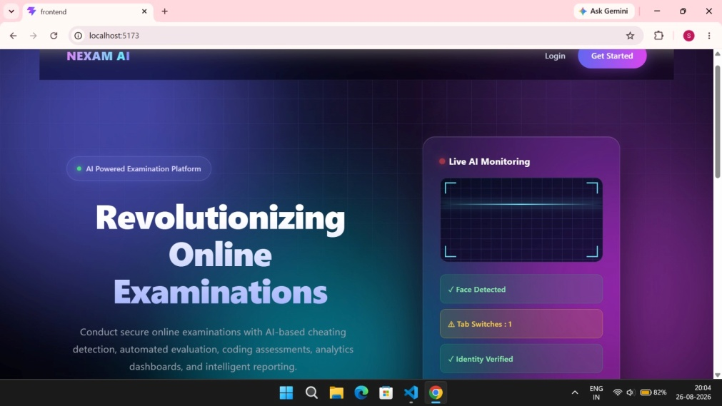  Figure 5.1: Landing page | 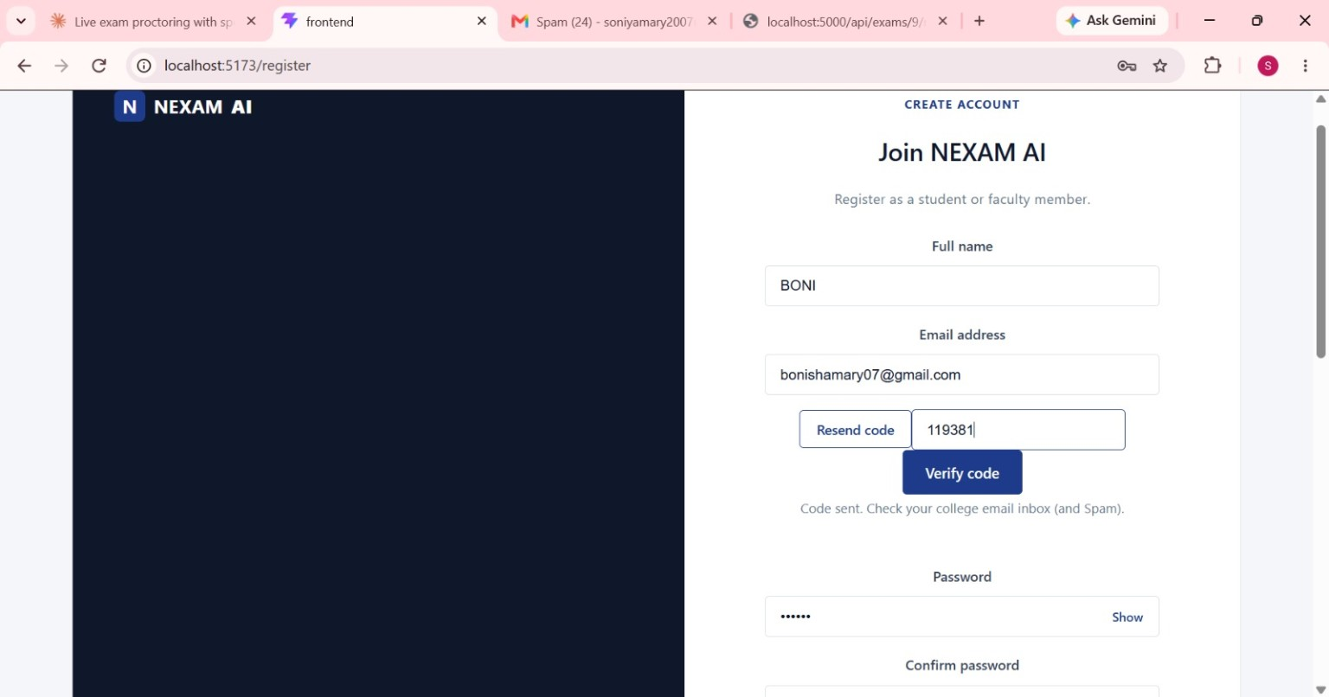  Figure 5.2: Registration with email verification code

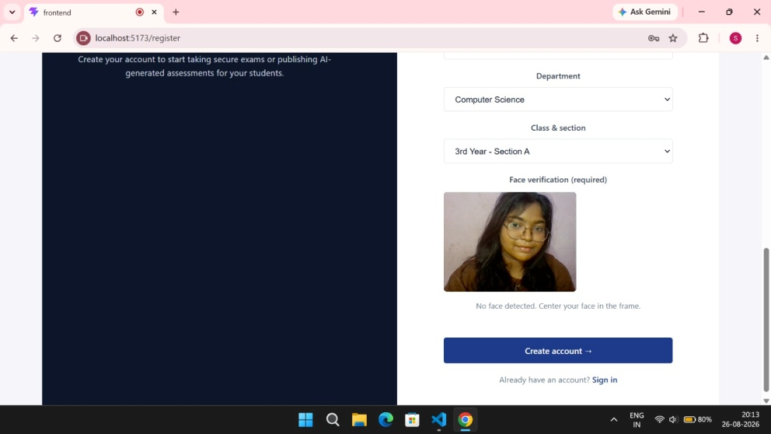  Figure 5.3: Face capture during registration | 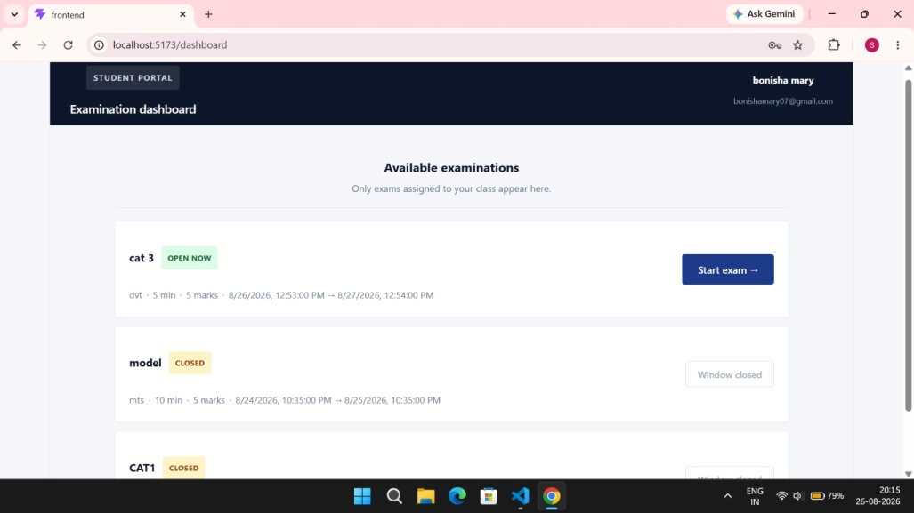  Figure 5.4: Student examination dashboard

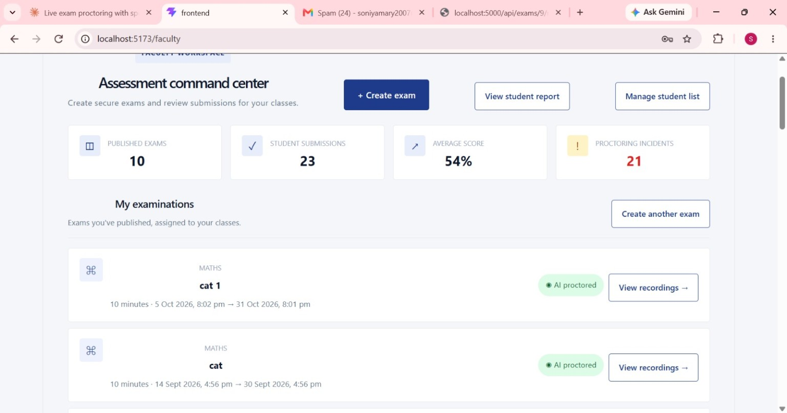  Figure 5.5: Faculty assessment command center | 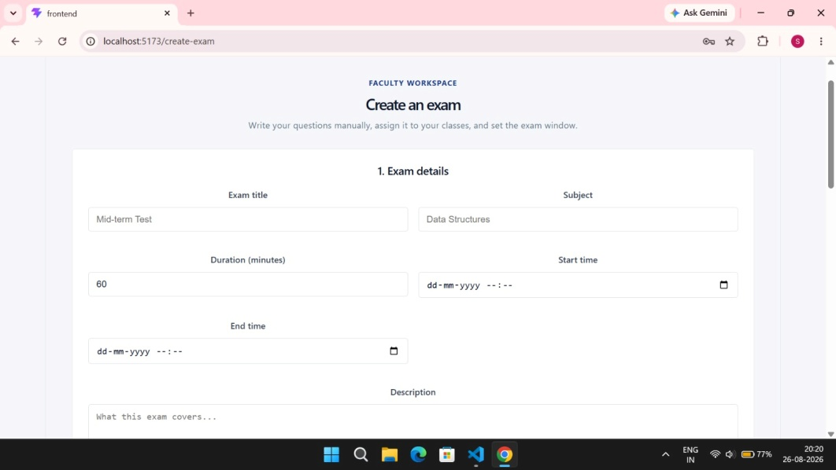  Figure 5.6: Create an exam – exam details

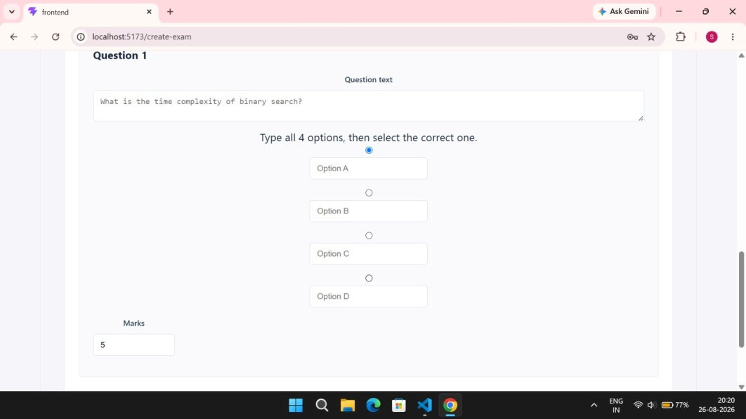  Figure 5.7: Adding an MCQ question | 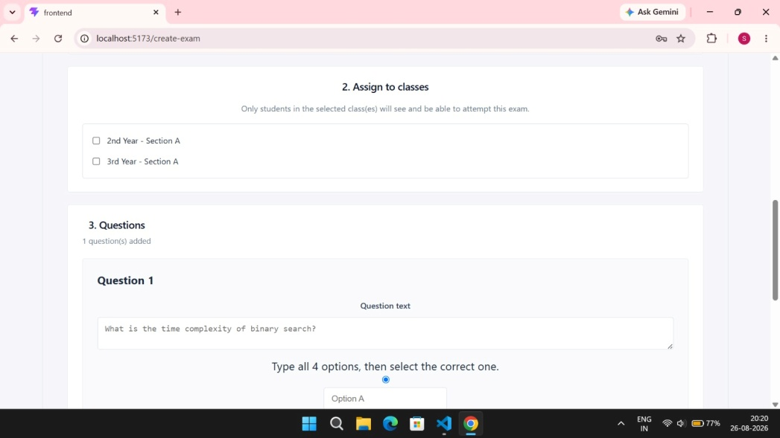  Figure 5.8: Assigning an exam to classes

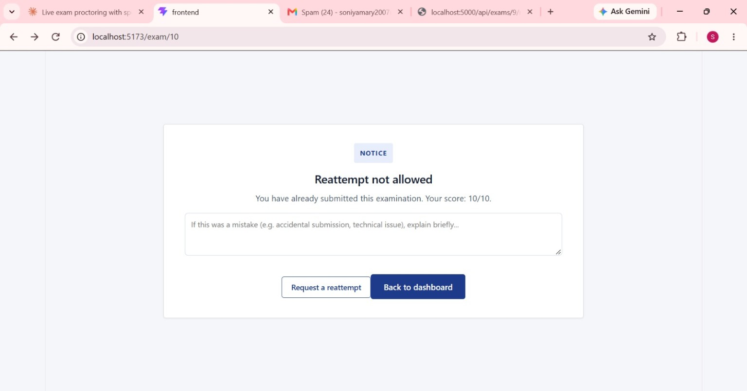  Figure 5.9: Reattempt notice and request | 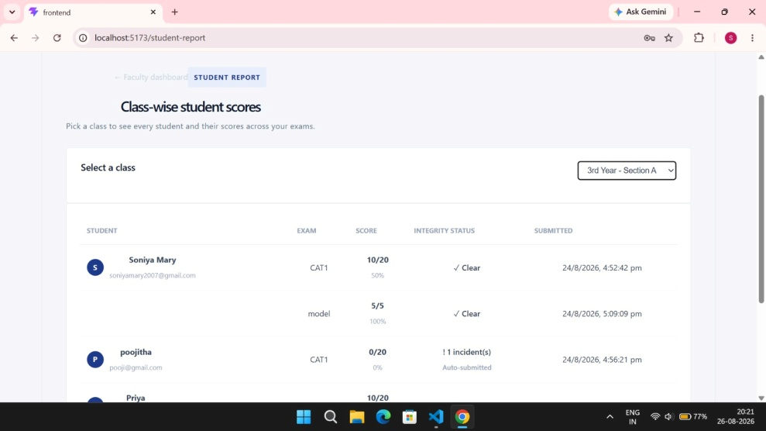  Figure 5.10: Class-wise report with integrity status

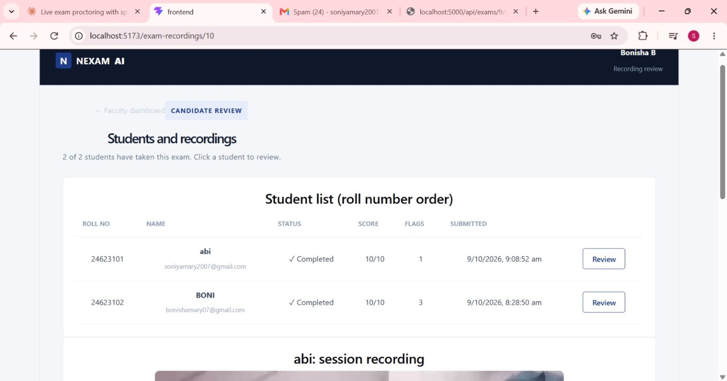  Figure 5.11: Students and recordings for review | 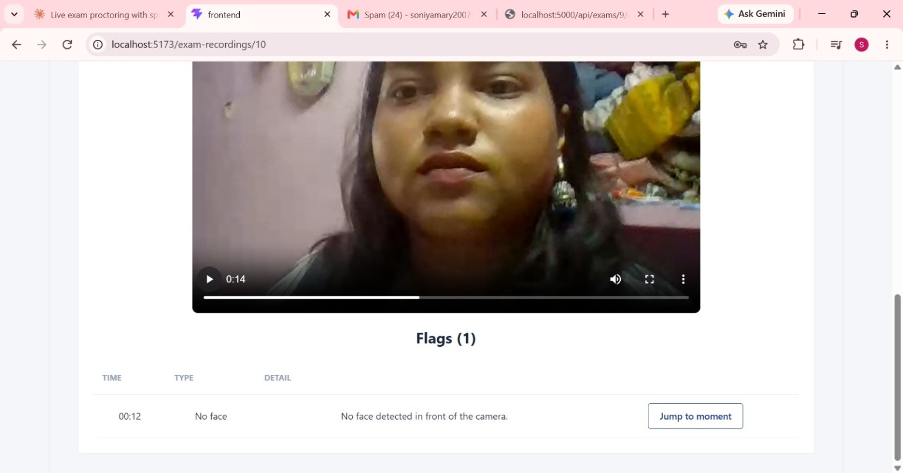  Figure 5.12: Session recording with a timestamped flag

Screenshots of the face verification step before an examination, the examination screen during monitoring, and a tab-switch or fullscreen violation are not yet available.

5.2 TEST PLAN AND TEST CASES
Testing covers functional testing of each module through the user interface, integration testing of the frontend with the API and database, and proctoring tests in which violations are deliberately triggered. Where a screenshot shows the expected behavior, the actual result cites it; all other cases are marked "Pending Testing" until they are executed and recorded.
Table 5.1: Test cases
ID | Feature | Input / action | Expected result | Actual result | Status
TC01 | Registration | Enter details; request code | Code emailed; "Code sent" shown | Shown in Figure 5.2 | Observed
TC02 | Email verification | Enter wrong code | Verification rejected | observed | observed
TC03 | Face capture | No face in frame | "No face detected" message; account not created | Message shown in Figure 5.3 | Observed
TC04 | Login | Valid / invalid credentials | Role dashboard / error | observed | observed
TC05 | Exam creation | Create exam with 1 MCQ, assign to class | Exam listed for faculty and class | Tested | observed
TC06 | Class filter | Student of unassigned class | Exam not listed | Tested | observed
TC07 | Exam window | Open dashboard after end time | "Window closed"; cannot start | Shown in Figure 5.4 | Observed
TC08 | Face verification | Different person at webcam | Exam not started / flagged | Pending Testing | observed
TC09 | Face monitoring | Leave camera view | "No face" flag with timestamp | Flag at 00:12 in Figure 5.12 | Observed
TC10 | Face monitoring | Second person in view | "Multiple faces" flag | observed | observed
TC11 | Tabmonitoring | Switch tab during exam | Tab-switch violation logged | observed | observed
TC12 | Fullscreen | Exit fullscreen | Fullscreen violation logged | observed | observed
TC13 | Auto-submission | Exceed violation rule | Exam auto-submitted | "Auto-submitted" in Figure 5.10 | Observed
TC14 | Evaluation | Submit known answers | Correct score and percentage | e.g. 10/20 = 50% in Figure 5.10 | Observed
TC15 | Reattempt | Reopen submitted exam | "Reattempt not allowed" with score; request form | Shown in Figure 5.9 | Observed
TC16 | Recording review | Click "Jump to moment" | Video seeks to flag time | observed | observed

5.3 TESTING RESULTS
Seven of the sixteen test cases (TC01, TC03, TC07, TC09, TC13, TC14 and TC15) show the expected behavior in the captured screenshots. These are observations from demonstration use, not results of a controlled test run. The remaining nine cases are pending. When formal testing is completed, the number of passed, failed and unexecuted cases should be reported, with the pass rate calculated as (passed ÷ executed) × 100. Face-verification accuracy, false-flag rate, frame rate and response times were measured.

5.4 DISCUSSION
The screenshots show that NEXAM supports the complete examination lifecycle in one application: verified registration with face capture, class-based assignment and exam windows, automatic scoring, class-wise reports, recordings with timestamped flags, and a reattempt path. The recording review addresses a gap identified in Chapter 2: alerts are linked to a specific submission and moment in the recording, so faculty can judge each incident in context. Compared with the base paper, which infers collusion from response data after the test [7], NEXAM observes the session directly; the two approaches are complementary. Compared with systems requiring worn cameras, fingerprint readers or eye trackers [4], [5], NEXAM needs only a webcam and a browser. As earlier studies show, behavioral indicators produce false flags [12], so NEXAM's design of presenting flags for faculty review rather than imposing automatic penalties is important.

5.5 ADVANTAGES OF THE SYSTEM
- Integrates examination management, identity verification, monitoring, evaluation and reporting.
- Runs in the browser with on-device facial analysis; no paid proctoring service or special hardware.
- Provides timestamped, reviewable evidence linked to each submission.
- Follows a college → department → class structure that suits institutional deployment.
- Gives immediate results for objective examinations.

5.6 LIMITATIONS
- Only objective (MCQ) questions are evaluated automatically.
- Face detection and matching depend on lighting, camera quality and pose, and can produce false positives and false negatives.
- Browser monitoring cannot detect a second device, printed notes or help outside the camera view.
- Formal test results and accuracy measurements have not yet been recorded.
- Features shown in the presentation design image (eye tracking, head pose, voice detection, screen capture, integrity score) are not confirmed in the implementation.
- Biometric data and recordings create privacy obligations that require clear consent, retention and access policies.

5.7 CONCLUSION
NEXAM is an intelligent examination management, assessment and proctoring platform that combines a React and TypeScript frontend, a Node.js and Express backend, an SQLite database and on-device facial analysis with face-api.js. The implemented system lets faculty create, assign and review examinations, lets students register with a verified email and face, take examinations within their class windows and request reattempts, and records timestamped integrity flags alongside session recordings for faculty review, with objective answers scored automatically. By building identity verification and monitoring into the examination flow and keeping faculty in control of decisions, NEXAM provides a low-cost, evidence-based approach to academic integrity in online examinations. Completing the pending tests and confirming the remaining monitoring features are the next steps toward deployment.

5.8 FUTURE ENHANCEMENTS
- Additional monitoring: head-pose and gaze estimation, object (phone) detection and speech-activity detection, as listed in the project plan.
- Response-pattern analysis: apply the base paper's answer-concordance and timing analysis to detect collusion across submissions [7].
- Wider evaluation: descriptive, image-based and coding questions.
- Risk scoring and notifications: combine flags into an integrity score and notify faculty by email.
- Institutional integration: connection with learning management systems such as Moodle.
- Privacy features: configurable retention, encrypted biometric storage and a student-facing consent and appeal workflow.

APPENDIX A-CONFERENCE PAPER CERTIFICATES

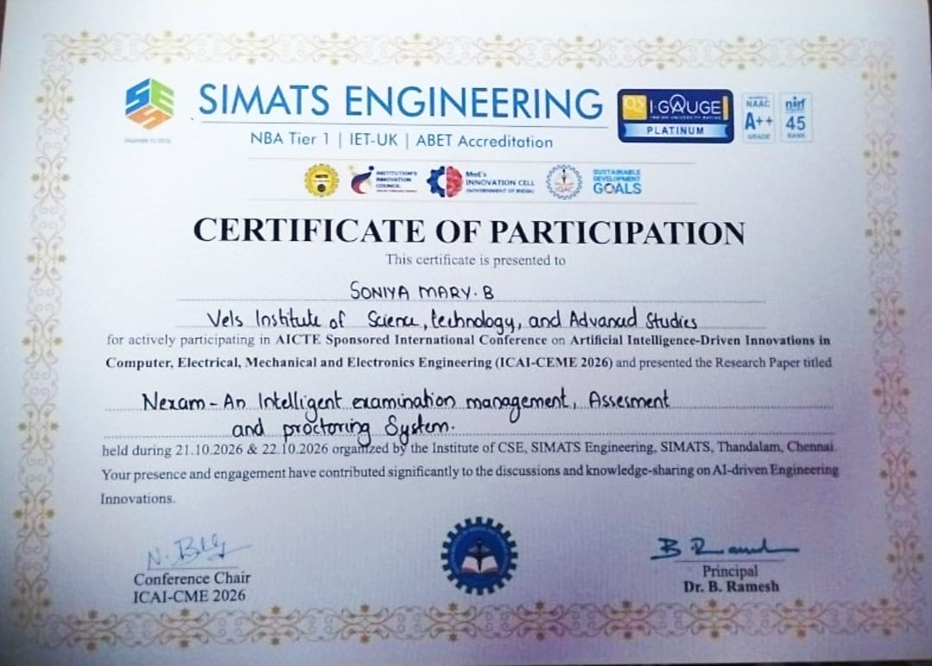
Certificate 1 - Soniya
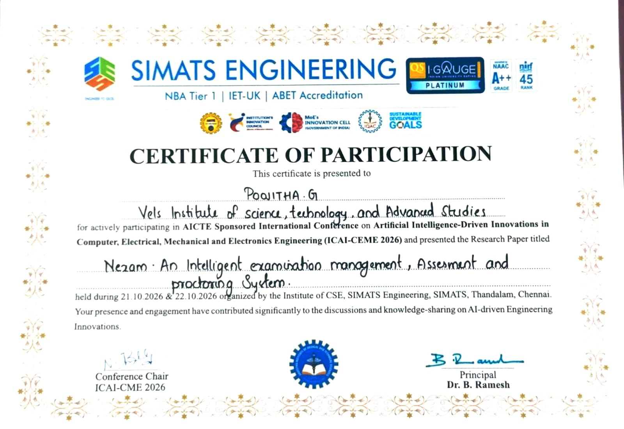
Certificate 2 - Poojitha
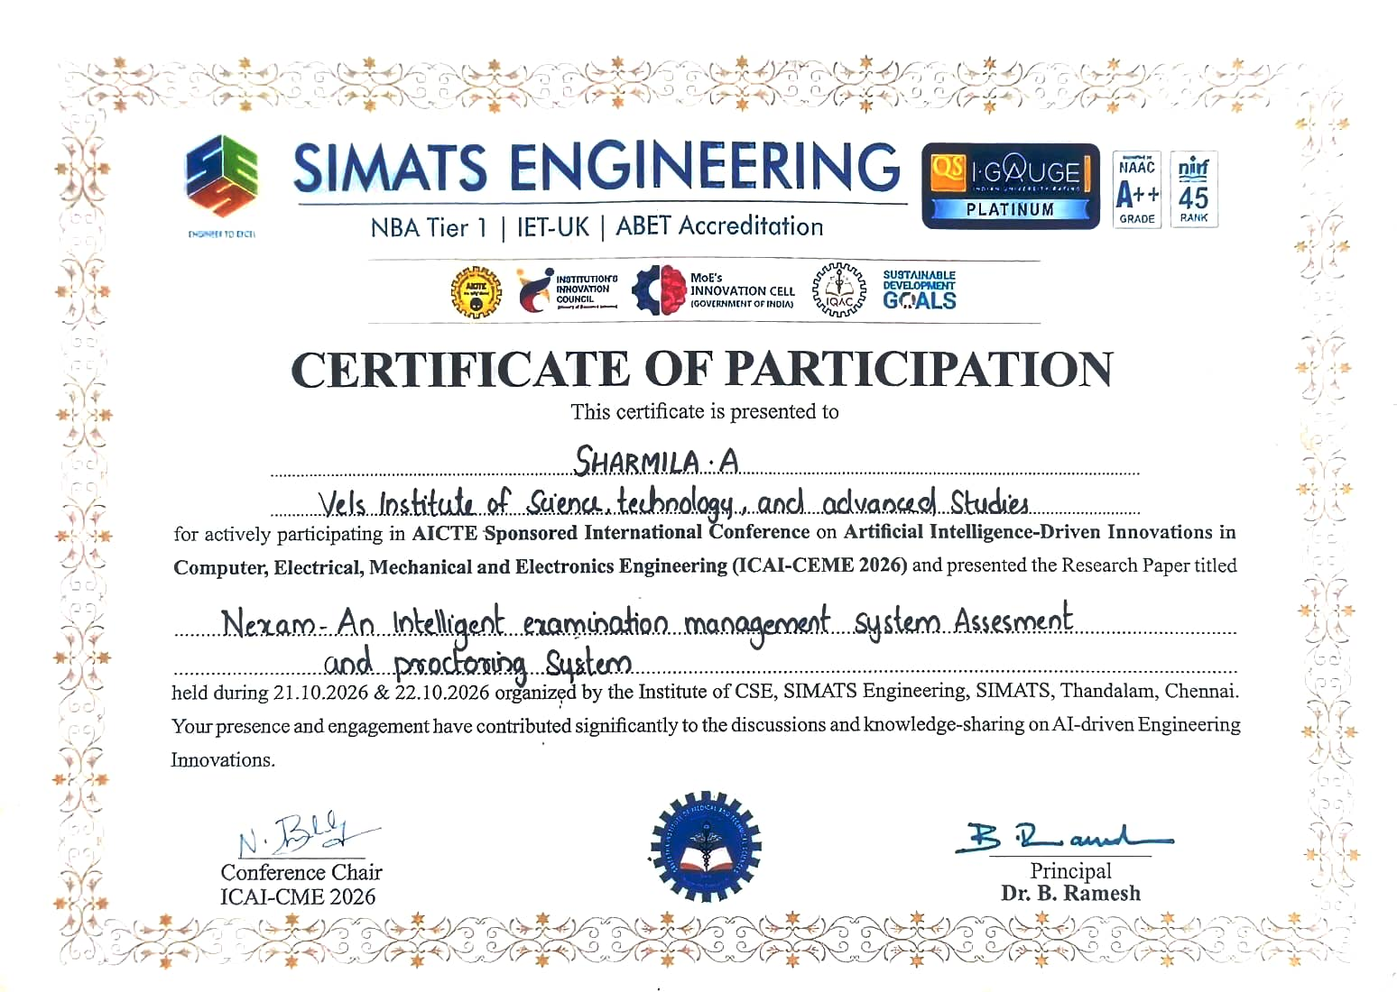
Certificate 3 - Sharmila

REFERENCES
[1] A. Nigam, R. Pasricha, T. Singh, et al., "A systematic review on AI-based proctoring systems: Past, present and future," Education and Information Technologies, vol. 26, pp. 6421–6445, 2021, doi: 10.1007/s10639-021-10597-x.
[2] V. Mühler, "face-api.js: JavaScript API for face detection and face recognition in the browser and Node.js with TensorFlow.js." [Online]. Available: https://github.com/justadudewhohacks/face-api.js
[3] S. Coghlan, T. Miller, and J. Paterson, "Good proctor or “Big Brother”? AI ethics and online exam supervision technologies," arXiv preprint arXiv:2011.07647, 2020.
[4] Y. Atoum, L. Chen, A. X. Liu, S. D. H. Hsu, and X. Liu, "Automated online exam proctoring," IEEE Transactions on Multimedia, vol. 19, no. 7, pp. 1609–1624, 2017.
[5] R. Bawarith, A. Basuhail, A. Fattouh, and S. Gamalel-Din, "E-exam cheating detection system," International Journal of Advanced Computer Science and Applications, vol. 8, no. 4, pp. 176–181, 2017.
[6] D. Smilkov, N. Thorat, Y. Assogba, et al., "TensorFlow.js: Machine learning for the web and beyond," in Proc. Machine Learning and Systems (MLSys), 2019.
[7] M. Carrasco, A. Rito Silva, and R. Henriques, "Detecting fraudulent student communication in a multiple choice online test environment," IEEE Transactions on Computational Social Systems, vol. 11, no. 1, Feb. 2024. [Online]. Available: https://ieeexplore.ieee.org/document/10077404
[8] F. Schroff, D. Kalenichenko, and J. Philbin, "FaceNet: A unified embedding for face recognition and clustering," in Proc. IEEE Conf. Computer Vision and Pattern Recognition (CVPR), 2015, pp. 815–823.
[9] D. E. King, "Dlib-ml: A machine learning toolkit," Journal of Machine Learning Research, vol. 10, pp. 1755–1758, 2009.
[10] G. Fenu, M. Marras, and L. Boratto, "A multi-biometric system for continuous student authentication in e-learning platforms," Pattern Recognition Letters, vol. 113, pp. 83–92, 2018, doi: 10.1016/j.patrec.2017.03.027.
[11] S. Prathish, A. Narayanan S, and K. Bijlani, "An intelligent system for online exam monitoring," in Proc. Int. Conf. Information Science (ICIS), Kochi, India, 2016, pp. 138–143, doi: 10.1109/INFOSCI.2016.7845315.
[12] C. Y. Chuang, S. D. Craig, and J. Femiani, "Detecting probable cheating during online assessments based on time delay and head pose," Higher Education Research & Development, 2017.
[13] MDN Web Docs, "Page Visibility API." [Online]. Available: https://developer.mozilla.org/en-US/docs/Web/API/Page_Visibility_API
[14] MDN Web Docs, "Fullscreen API." [Online]. Available: https://developer.mozilla.org/en-US/docs/Web/API/Fullscreen_API
[15] MDN Web Docs, "MediaStream Recording API." [Online]. Available: https://developer.mozilla.org/en-US/docs/Web/API/MediaStream_Recording_API
[16] SQLite, "About SQLite." [Online]. Available: https://www.sqlite.org/about.html
[17] OpenJS Foundation, "Express – Node.js web application framework." [Online]. Available: https://expressjs.com
[18] Meta Open Source, "React documentation." [Online]. Available: https://react.dev

